SIT result
FOR
Volunteer Management System
(VMS)

CLIENT | Liu Peishan
PROJECT | Volunteer Management System (VMS)
TITLE | SIT result
VERSION | 1.0
DATE | 30-Dec-2011
ORIGINATOR
Name / Signature |  | Team 8S
APPROVAL
Name / Signature |  | Phung Kim Cuong, Dio
Institute of Systems Science |  |  | Document Reference
25 Heng Mui Keng Terrence  Singapore 119615 |  |  | VMS/T-1.7.1/1

 | Acceptance
 | Customer Signature |  | Customer Signature
 | Name & Designation |  | Name & Designation
 | Date & Company Stamp |  | Date & Company Stamp

Revision History

Date | Version | Description | Author
30-Dec-2011 | 1.0 | Creation | Team 8S

Table of Contents

1. Test case report 3
2. Total defect report 3
3. Remaining defect report 4
ANNEX A Test case result report 5
ANNEX D Amendment History 6

Test case report

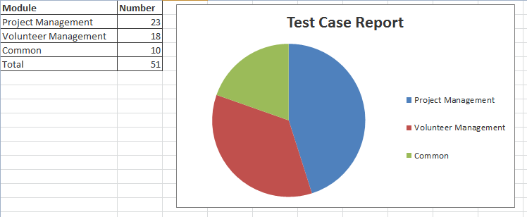
Figure 1 Test case coverage report

Total defect report

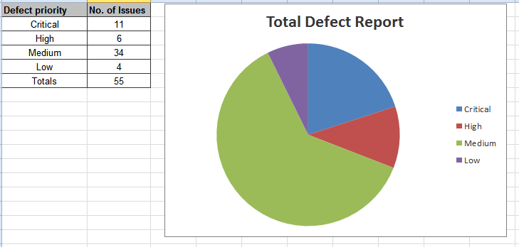
Figure 2 Total Defect Report

Remaining defect report
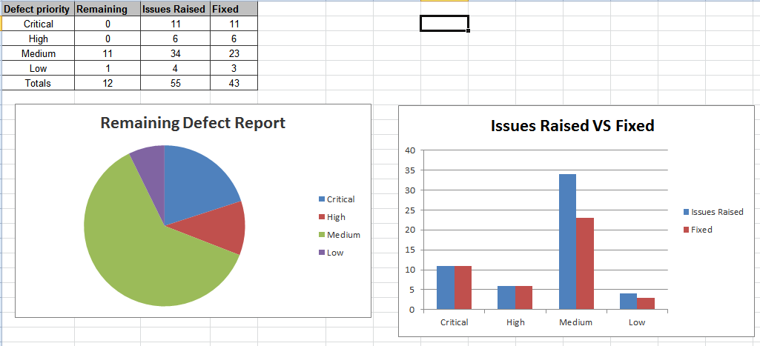
Figure 3 Remaining defect report

ANNEX A Test case result report

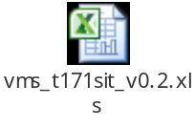

ANNEX D Amendment History

This is a record of all amendments made to the Document.
Version | Chapter / Section | Page No | Notes of Amendments or Changes

